



**Contents**

**INTRODUCTION TO TABLEAU** **2**

Summary 2

**BASIC CHARTS** **3**

Read in data 3

Our First Graph 6

Create a more meaningful measure 7

Add Aesthetics – play around with colour! 9

Inspect a Specific Data Point of Interest 10

Points are a different way of representing data 11

Exercise 11

Drilling Down 12

Show Sub-categories 12

Segment by Colour 13

Dealing with Dates 13

A Step Back to see the Big Picture 15

Using Interactivity for Impact 15

Using Colour for Impact 17

Test-Drive 17

**MAPS** **18**

Test Drive 23

**Dashboards** **24**

Test Drive 25

# INTRODUCTION TO TABLEAU

## Summary

You will learn:

1. How to create graphs in Tableau
2. How to create maps in Tableau
3. How to piece graphs together into a coherent Dashboard or Story for Presentations

# BASIC CHARTS

## Read in data

* Welcome to Tableau
* Read Data

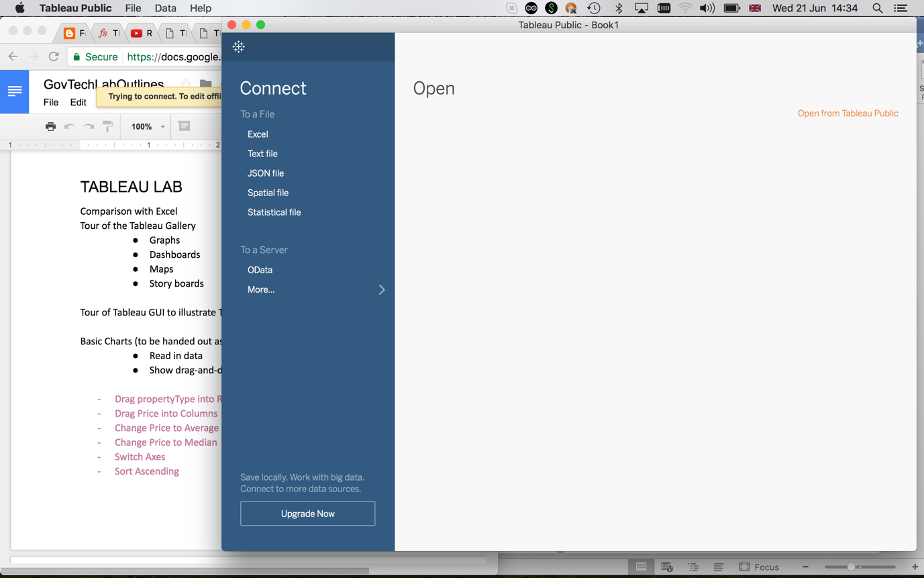

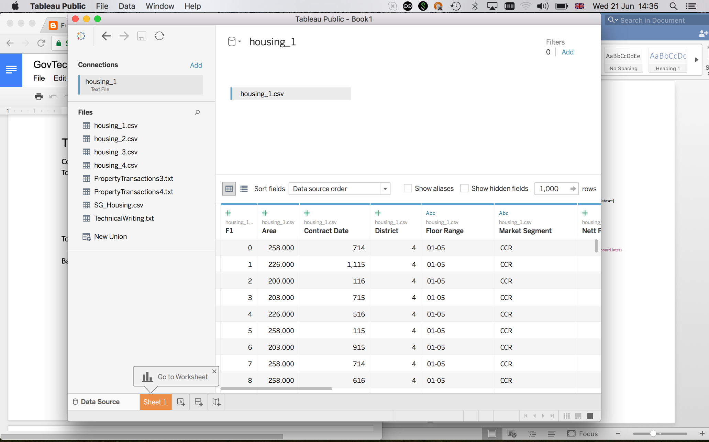

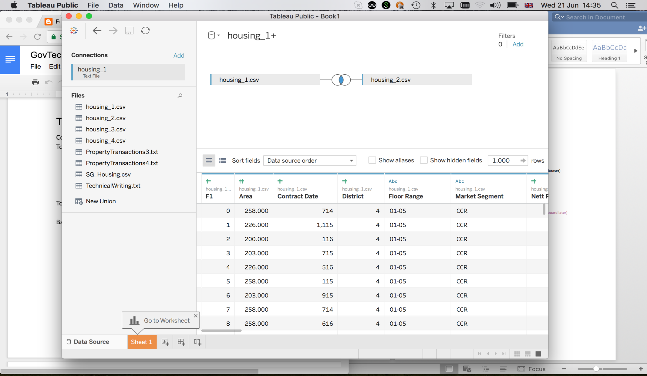

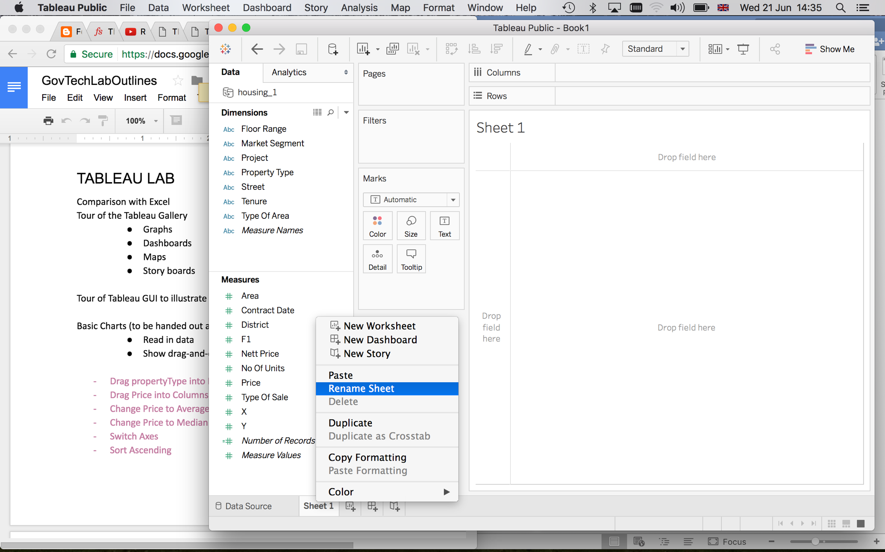

## Our First Graph

* Drag propertyType into Rows
* Drag Price into Columns

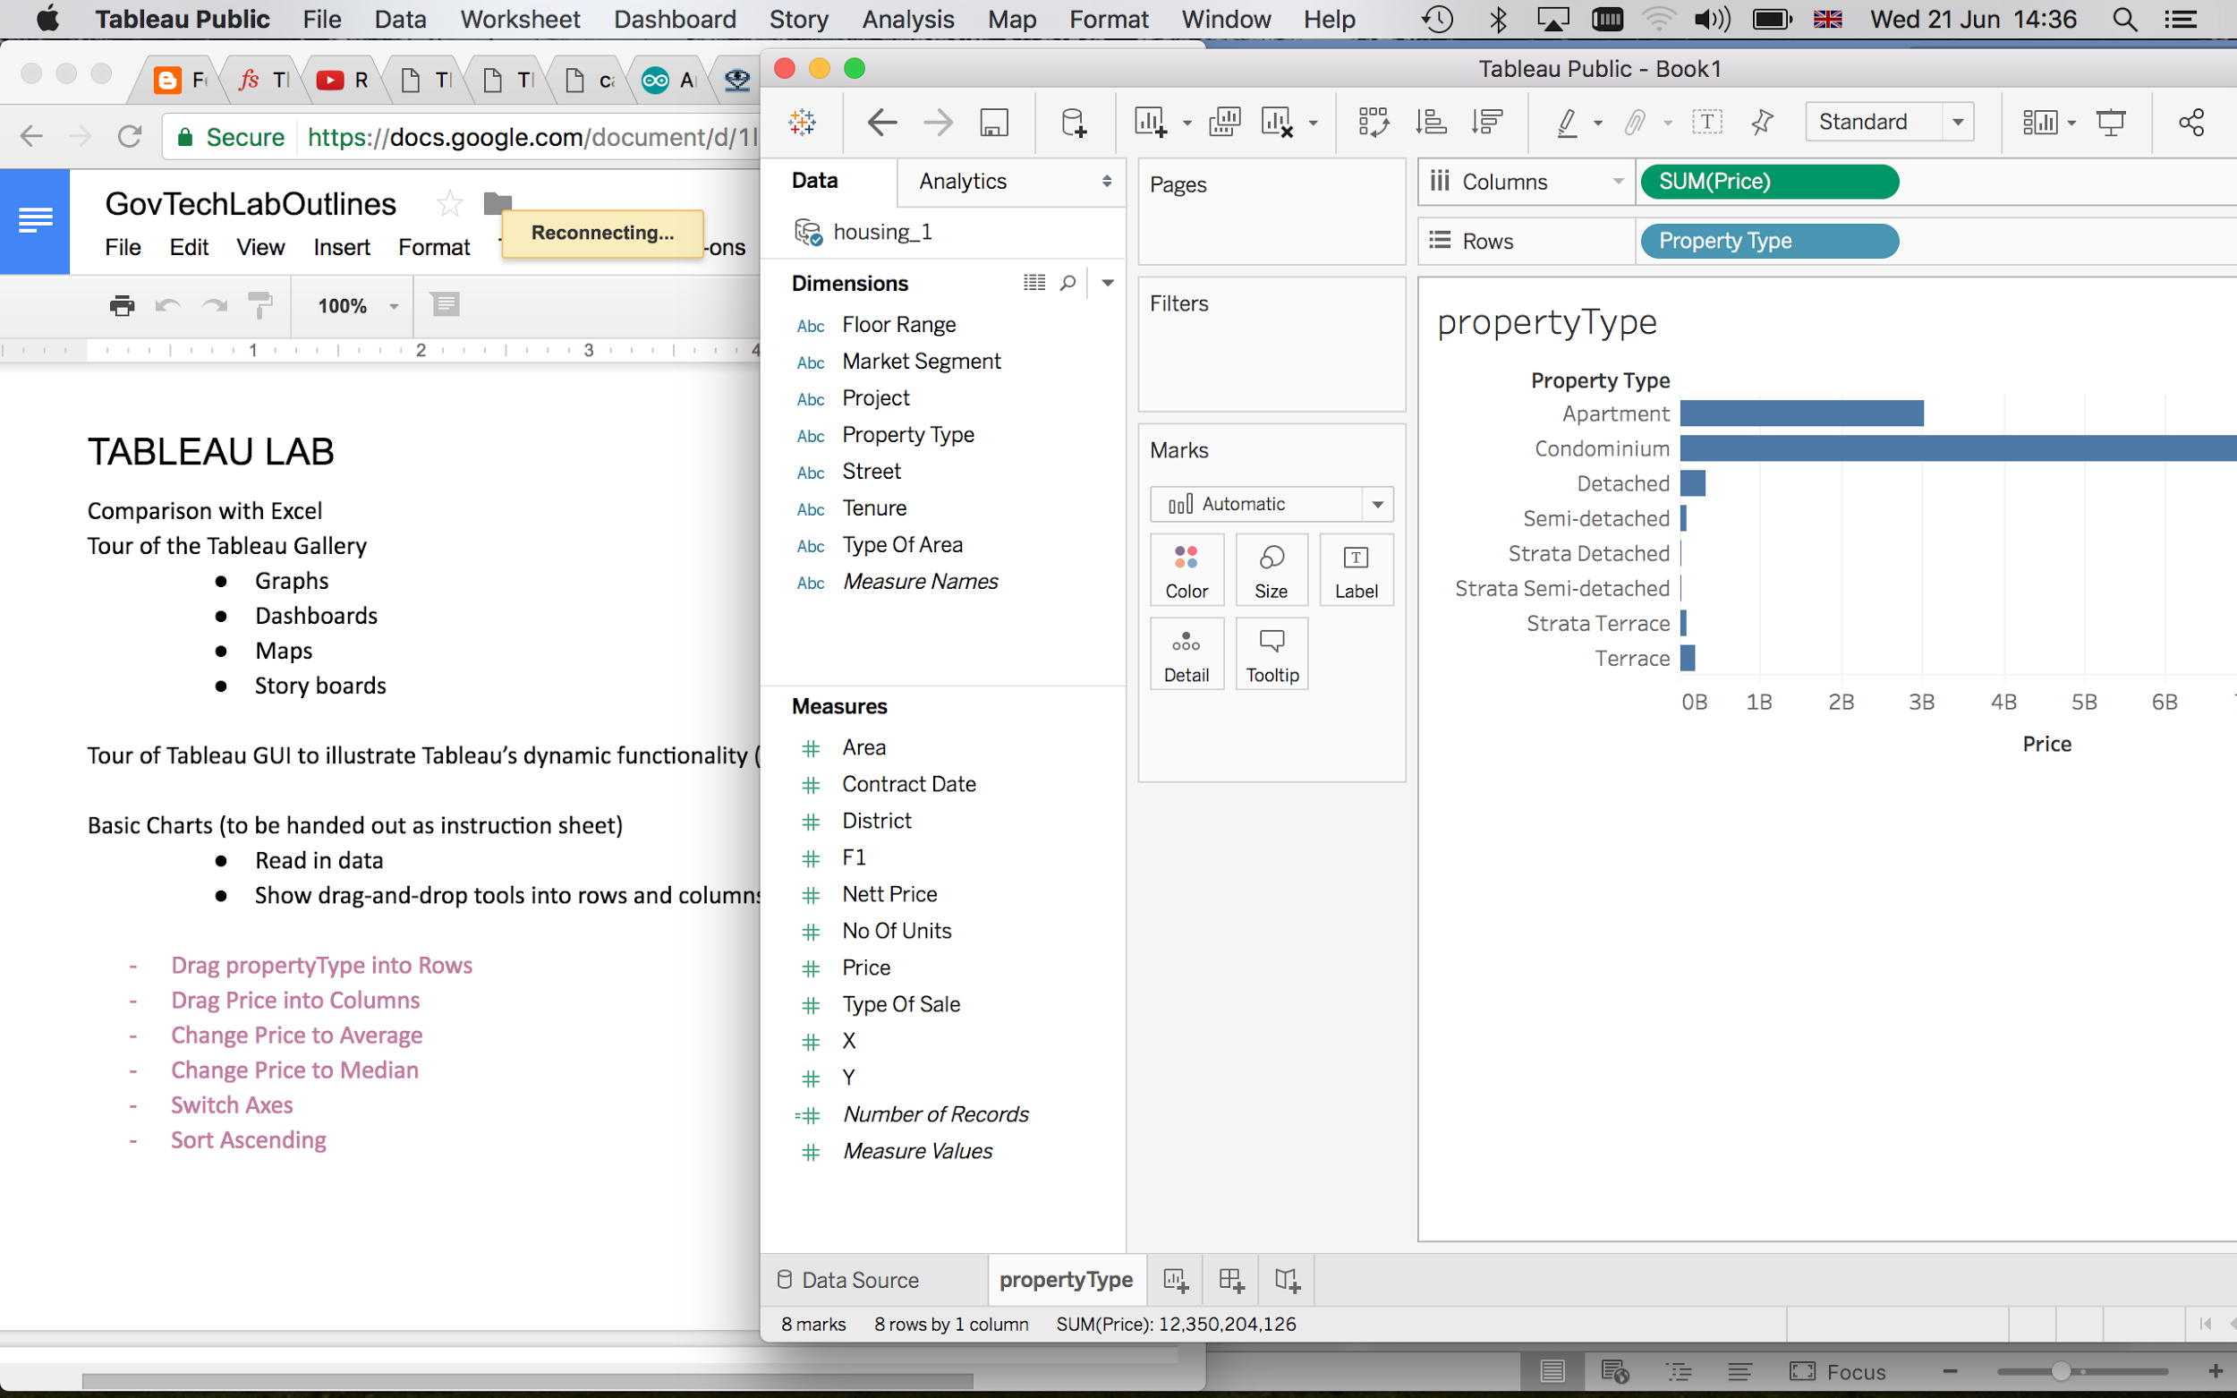

## Create a more meaningful measure

* Change Price to Average
* Change Price to Median

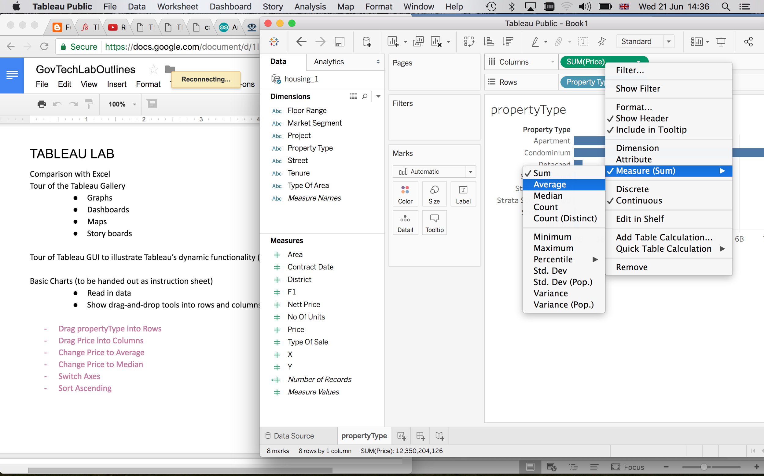

* Sort Descending

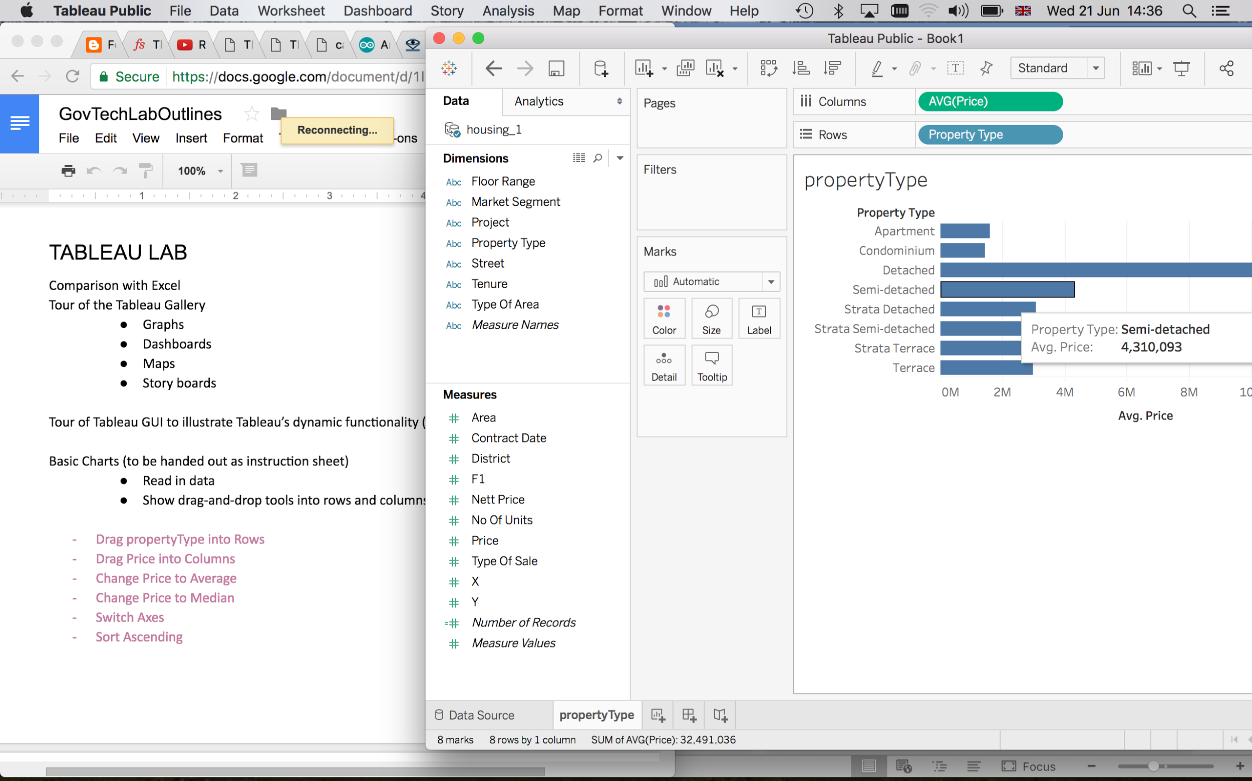

First insight – Looks like Detached Houses are much more expensive than other options

## Add Aesthetics – play around with colour!

* Change Colour
* Add Axes Labels
* Add Title

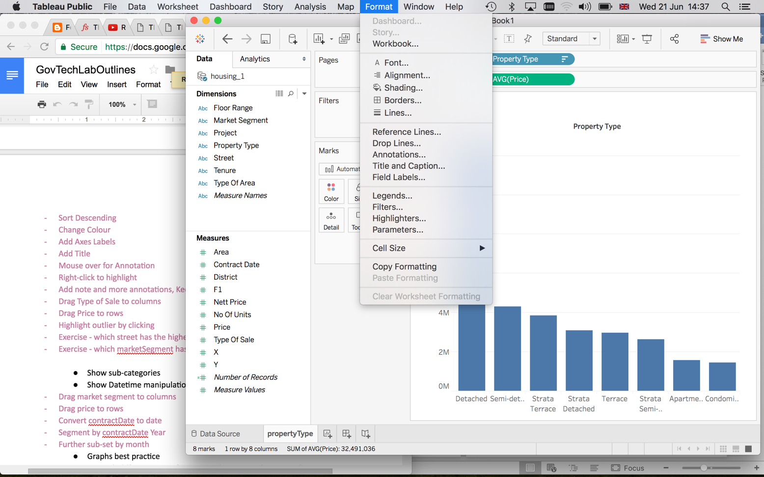

## Inspect a Specific Data Point of Interest

If Detached Houses are so expensive, what about the second-best option?

* Mouse over for Annotation
* Right-click to highlight
* Add note and more annotations, Keep Only, Exclude etc.

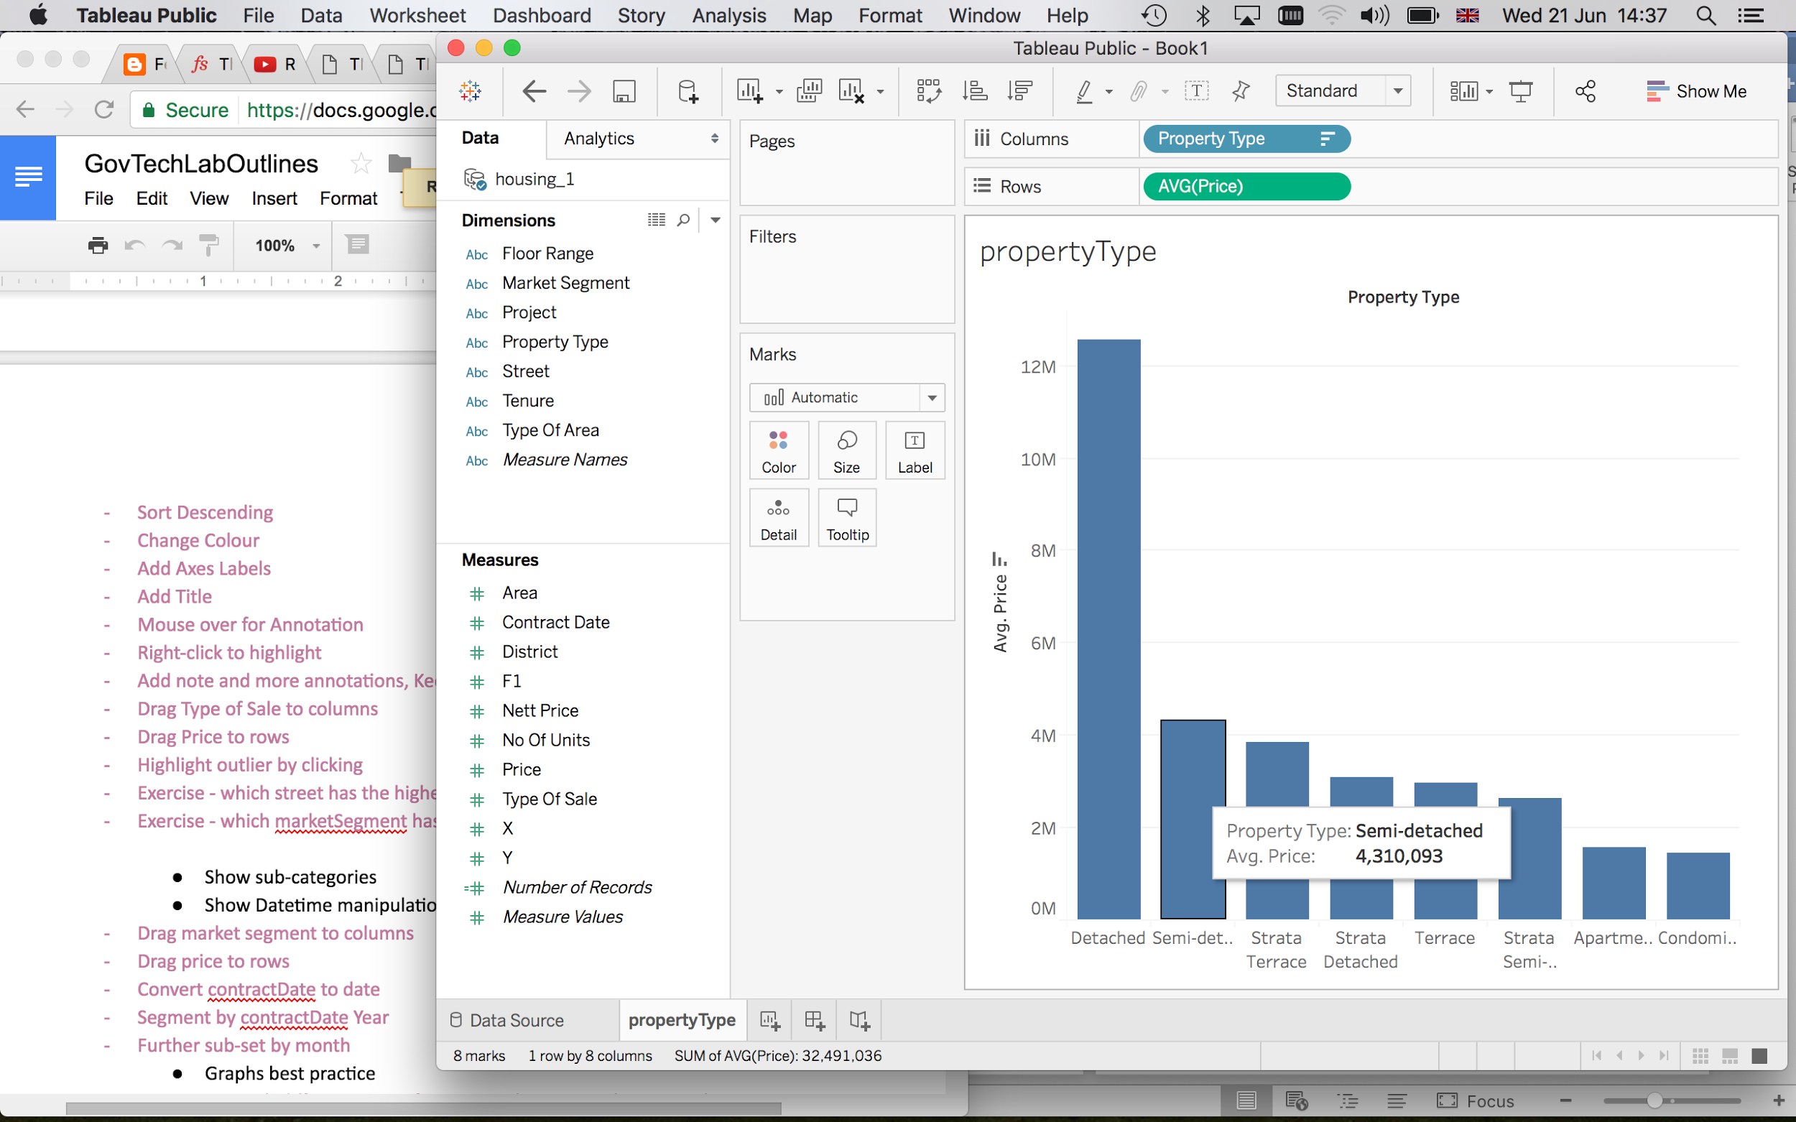

## Points are a different way of representing data

* Drag Type of Sale to columns
* Drag Price to rows
* Highlight outlier by clicking

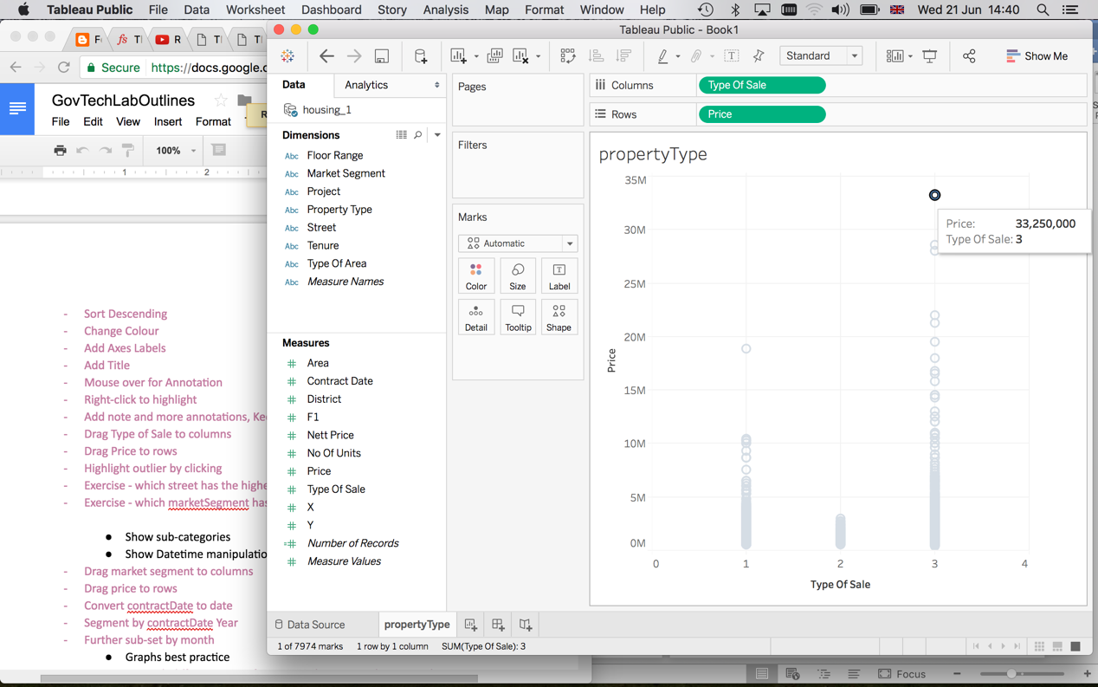

## Exercise

* Which street has the highest price?
* Which marketSegment has the lowest price?

## **Drilling** **Down**

* Show sub-categories
* Datetime manipulation

## Show Sub-categories

* Drag market segment to columns
* Drag Type of Area to columns
* Drag Price to Rows

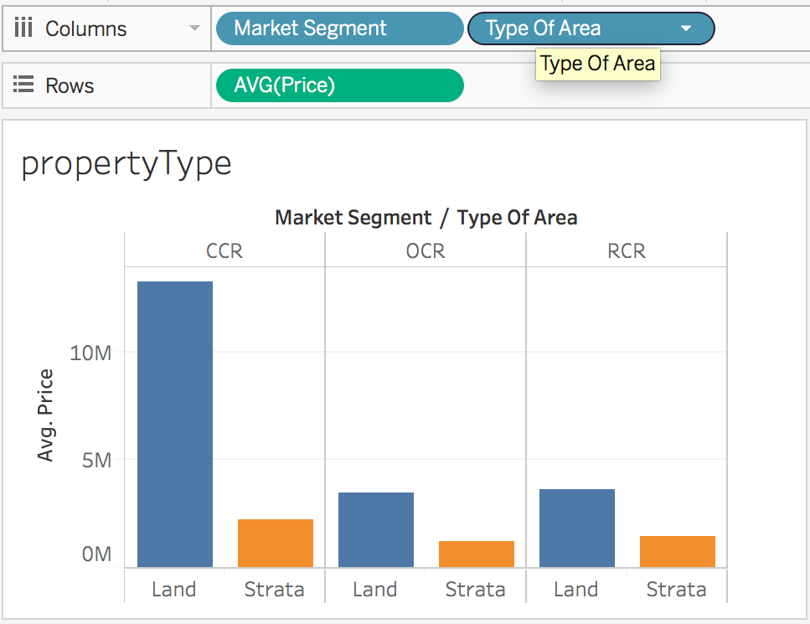

Looks like CCR and Land are a potent combination

## Segment by Colour

* Drag Type of Area to the Colour Box

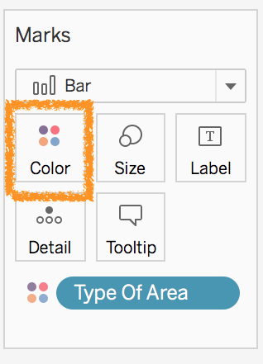

## Dealing with Dates

* Drag marketSegment to columns
* Drag Type of Area to columns
* Convert contractDate to date

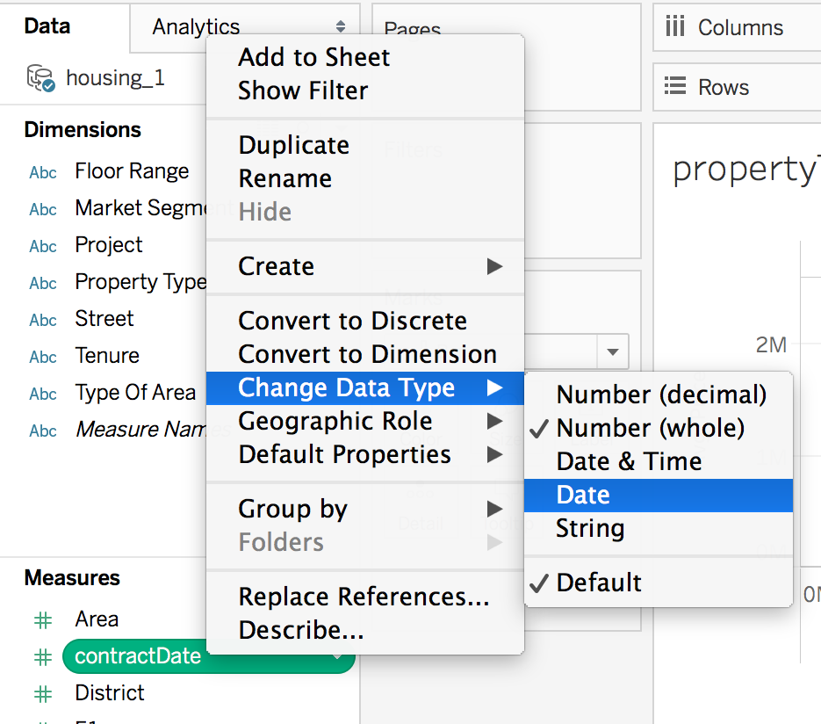

* Segment contractDate by Year

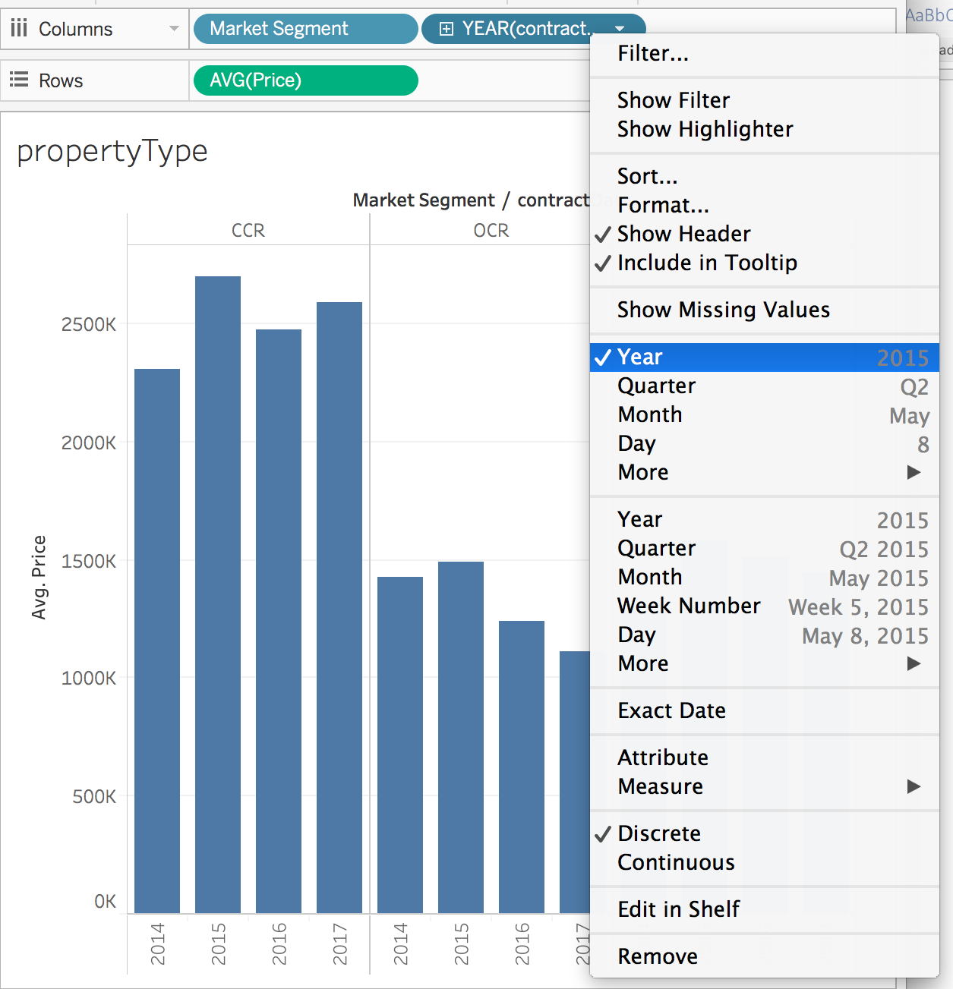

* Further sub-set by Quarter by clicking the ‘+’ sign next to Year

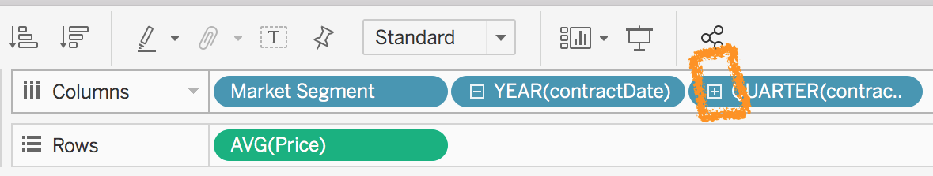

## **A Step Back** to see the Big Picture

* Graphs best practice
  + Experiment with different ways of portraying bars using Show Me tab
  + Show comparisons
  + Show change

## **Using Interactivity** for Impact

* Filters
  + Drag street to columns
  + Drag Tenure to columns
  + Drag price to rows
  + Drag street to filters
  + Drag tenure to filters

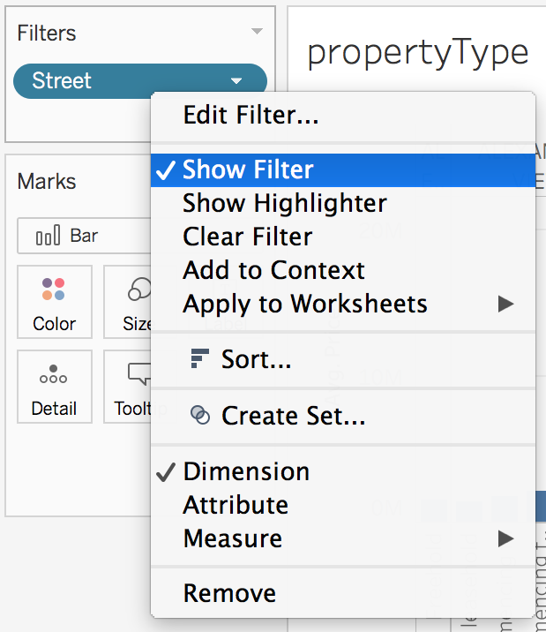

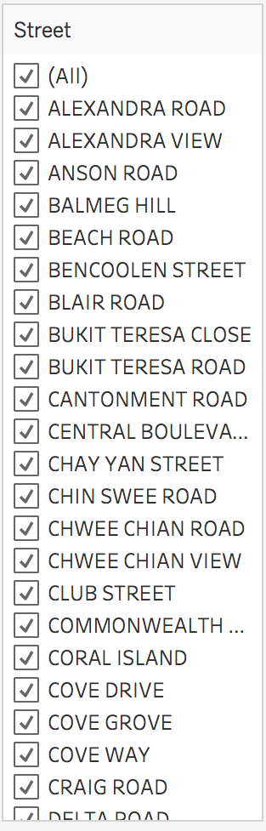

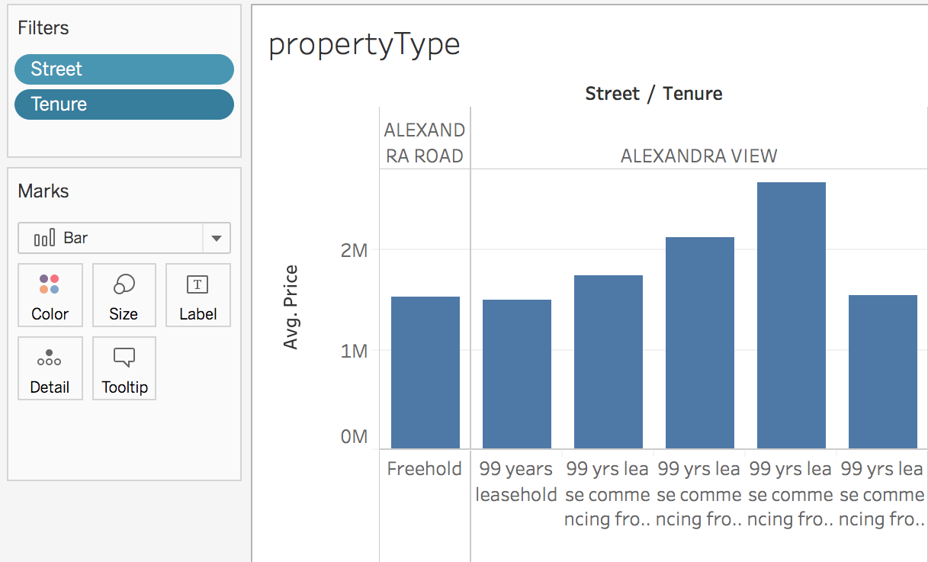

## Using Colour for Impact

* Add Price to Colours to highlight property prices

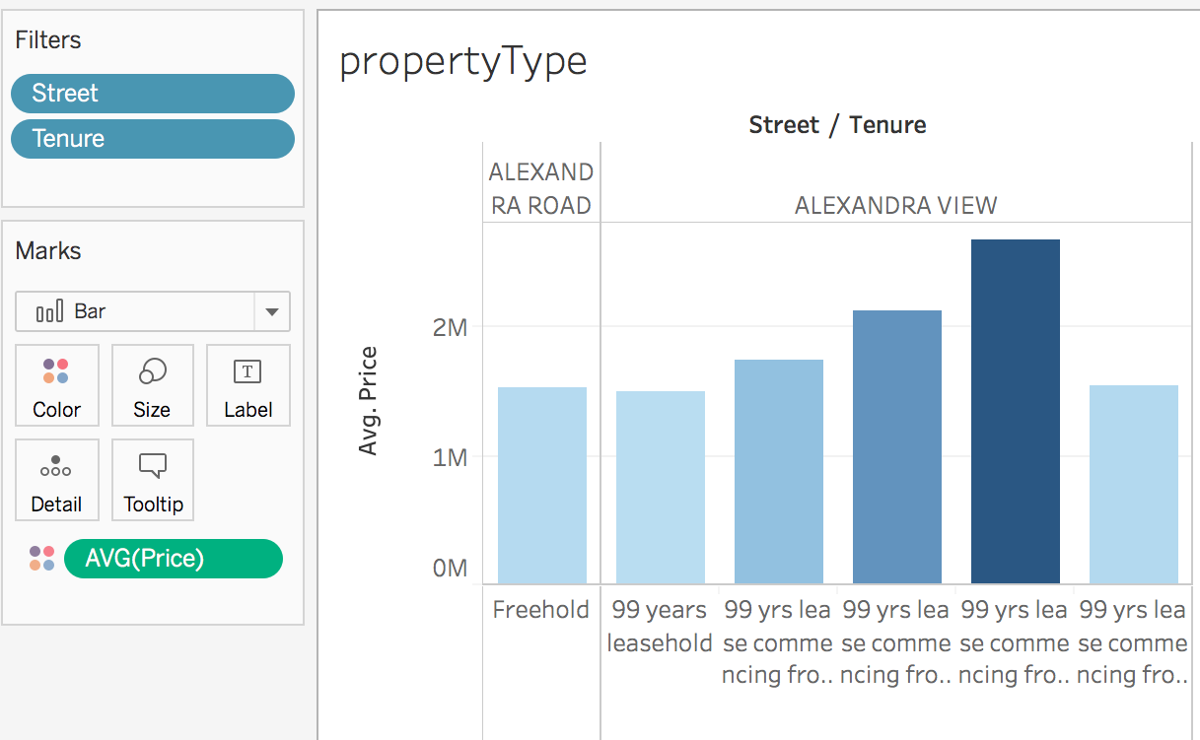

* Take-away – Tableau’s drag-and-drop functionality allows us to rapidly generate graphs and explore data

## 

## Test-Drive

* HDB_2013 dataset
* Tasks
  + Which town has the largest elderly population?
  + Which town has the highest number of primary schools?
  + Which town is most expensive to live in?

# MAPS

* Read KML shape files

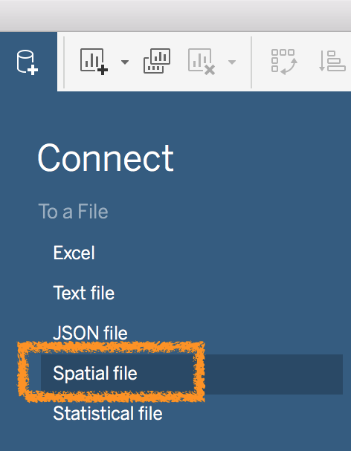

* Inspect KML File

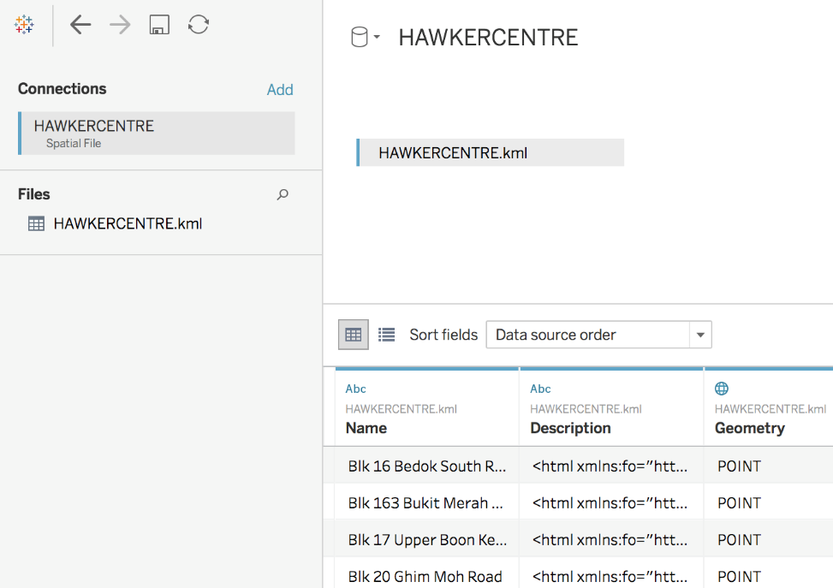

* Drag Longitude to Columns
* Drag Latitude to Rows
* Drag Geometry to Detail

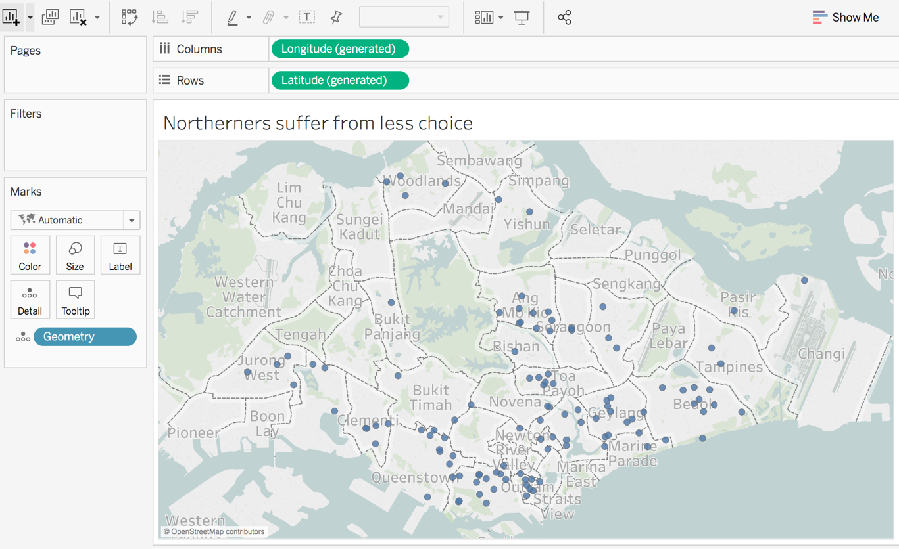

* Drag Name to Detail

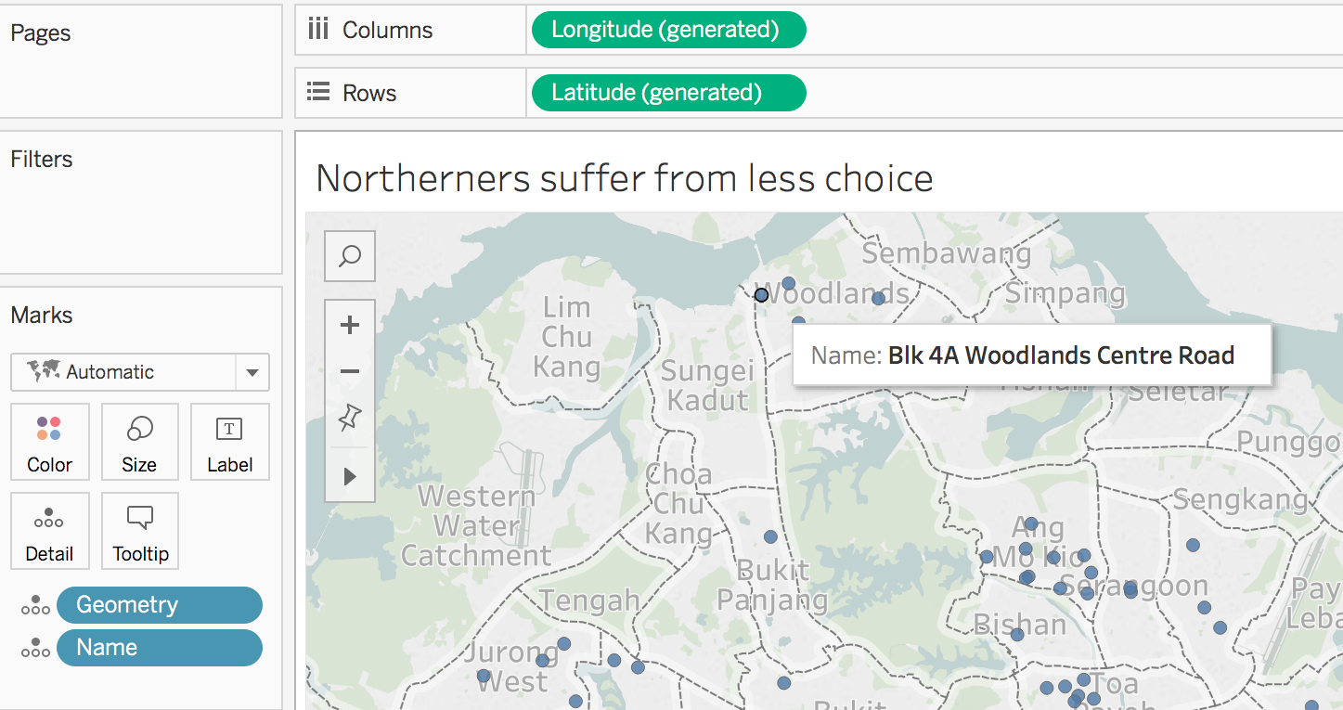

* Tour of Tableau Help looking at blending geographic data

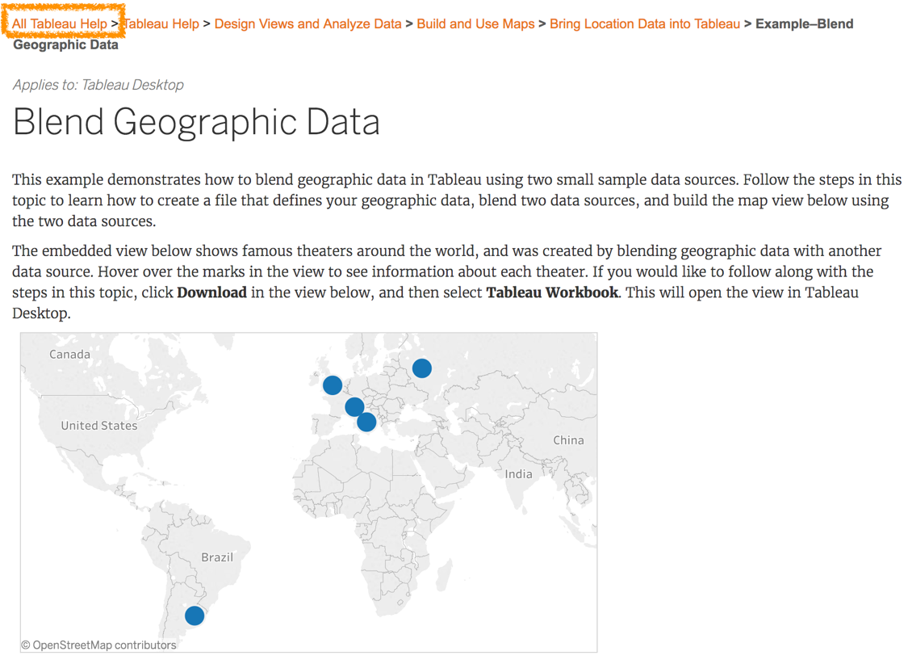

* Access map layers from map to customise look

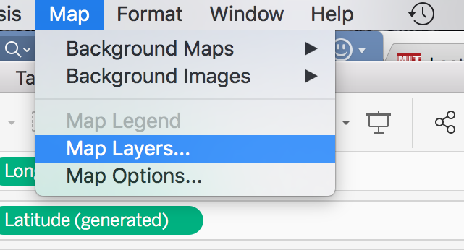

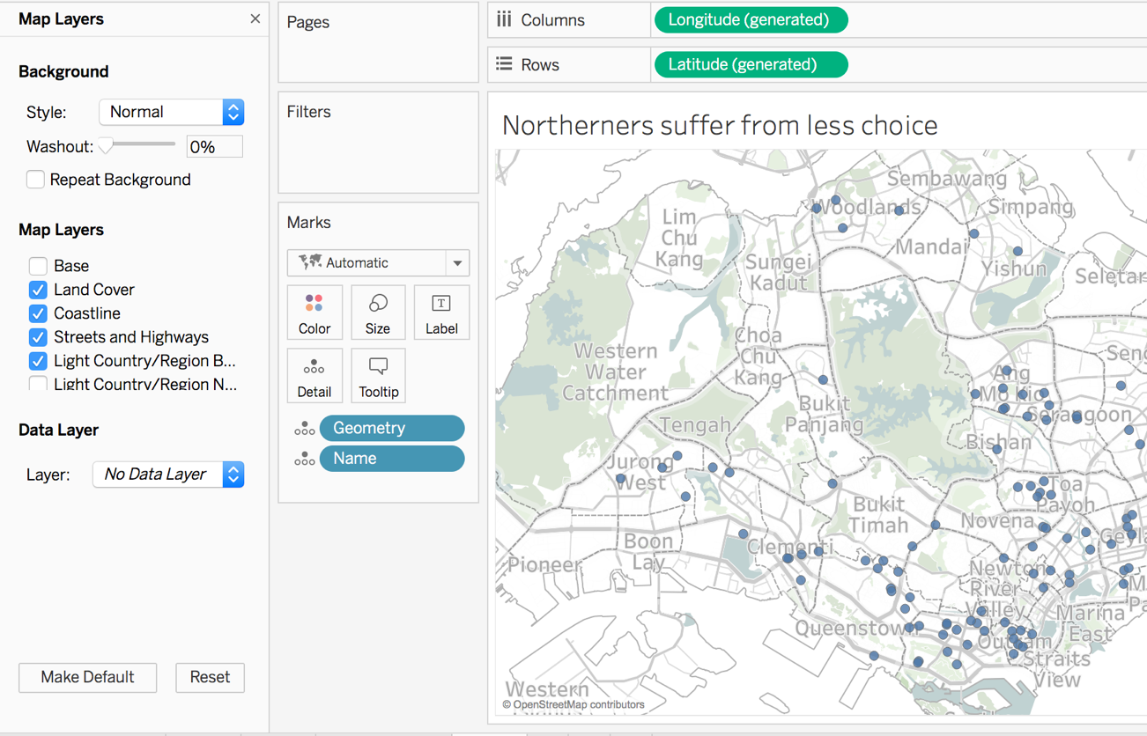

* Non-Geospatial Files
  + Tableau can also recognise coordinates from Excel Files
  + Read in Clean_HDB_2013_Geo

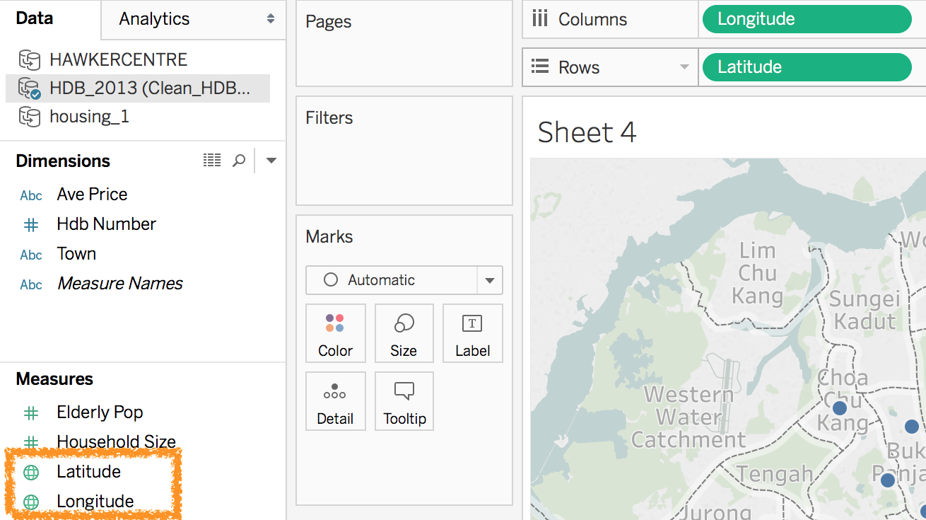

* Represent data on a map (note: although maps are visually interesting, these circles don’t actually communicate well. If we follow recommended design principles, a simple bar graph would probably work better)

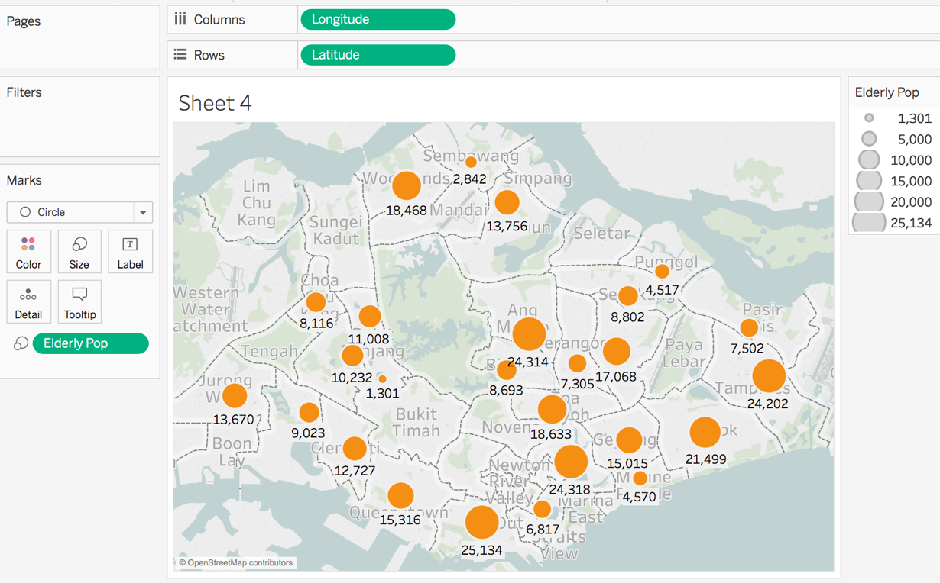

* Add filter to drill down to specific area (this allows us to create dashboard later)

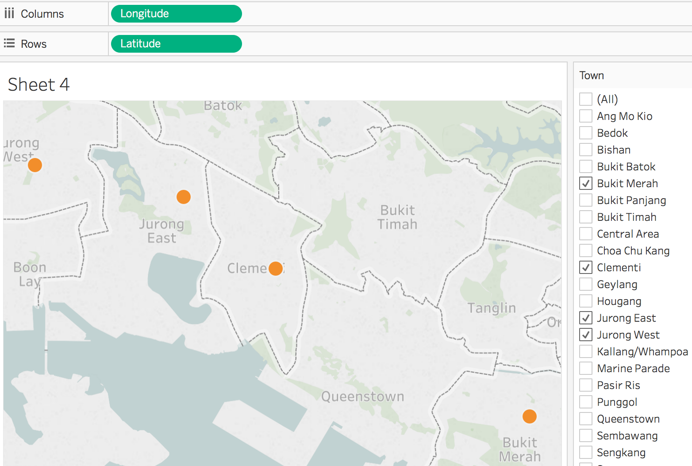

## 

## Test Drive

* Access data from govtech open data
* Download KML file
* Read into Tableau
* Create a map
* As we break for lunch, think of what story you want to tell with the data

# 

# 

# Dashboards

* Combine findings into dashboards
  + Dashboards present findings cohesively
  + Click on the Dashboard Icon (orange circle) to create a dashboard

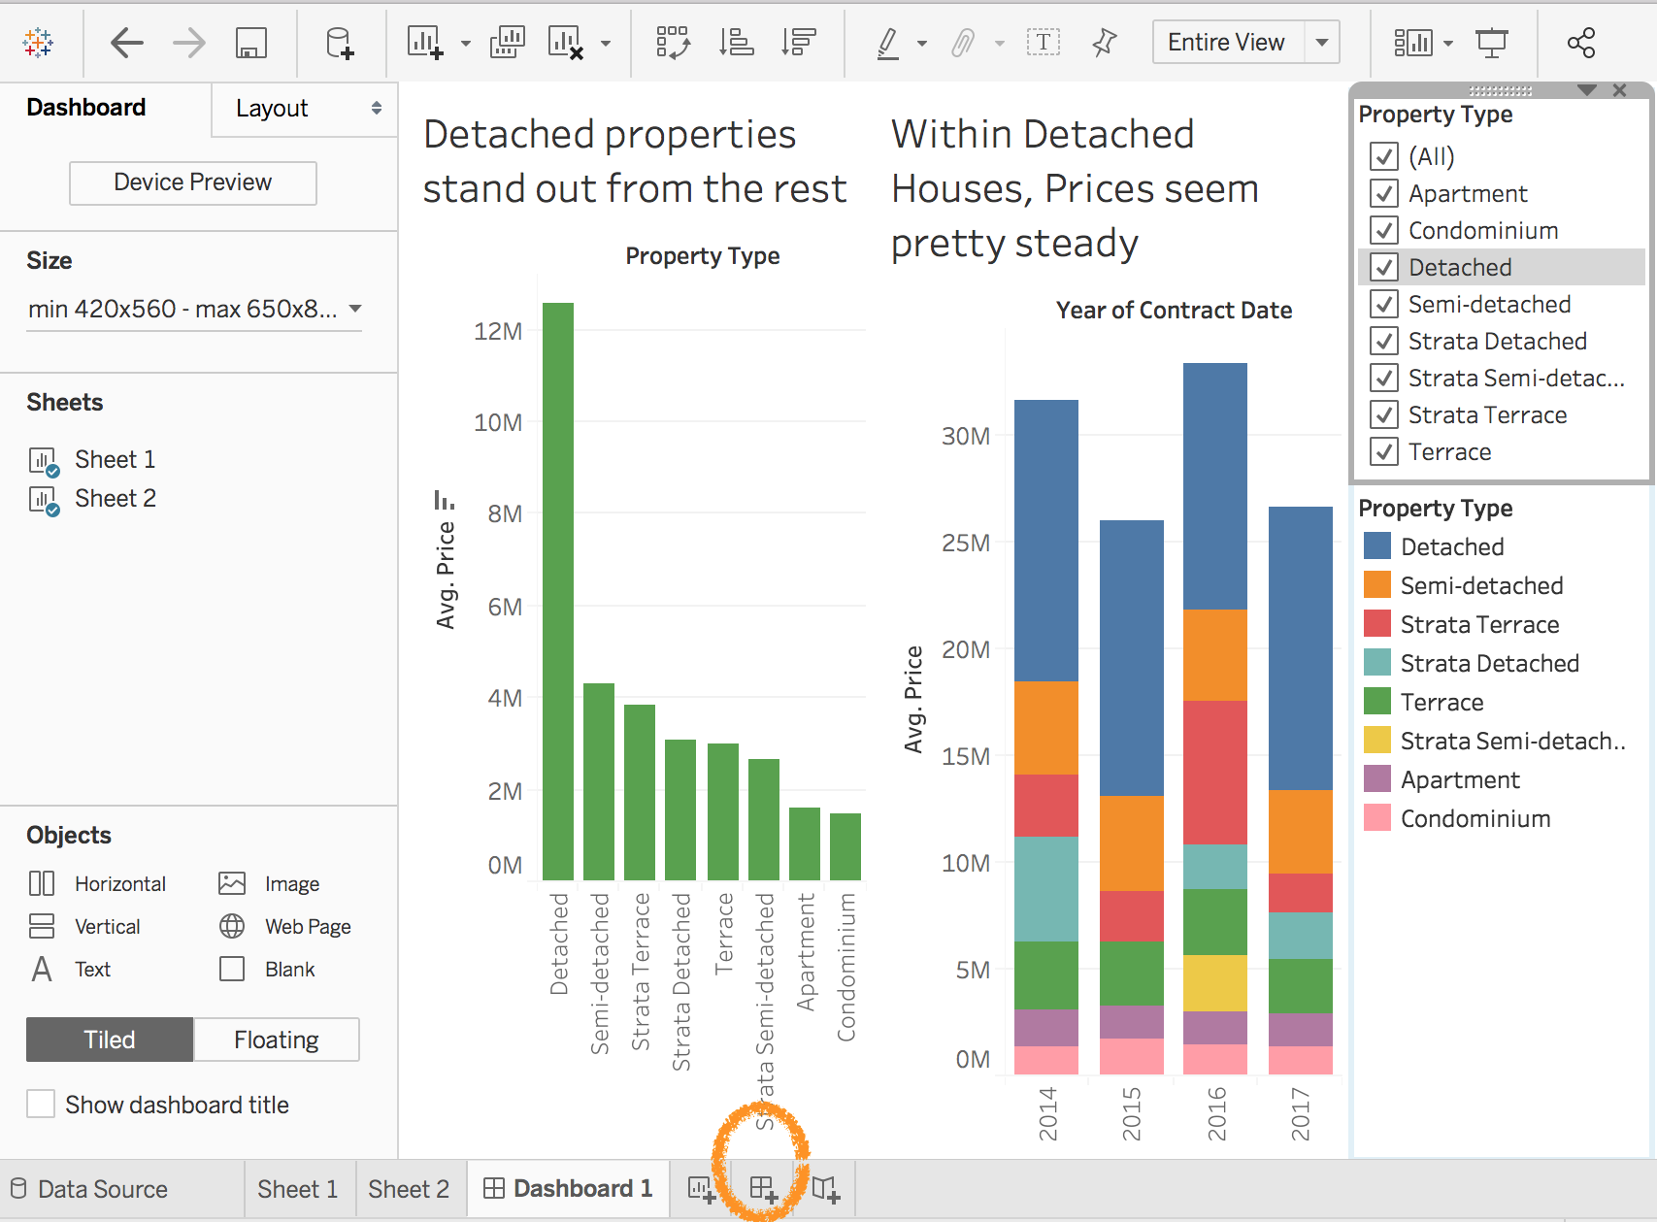

* Dashboards are also interactive
* Dashboarding Design Principles and Best Practice (see slides)

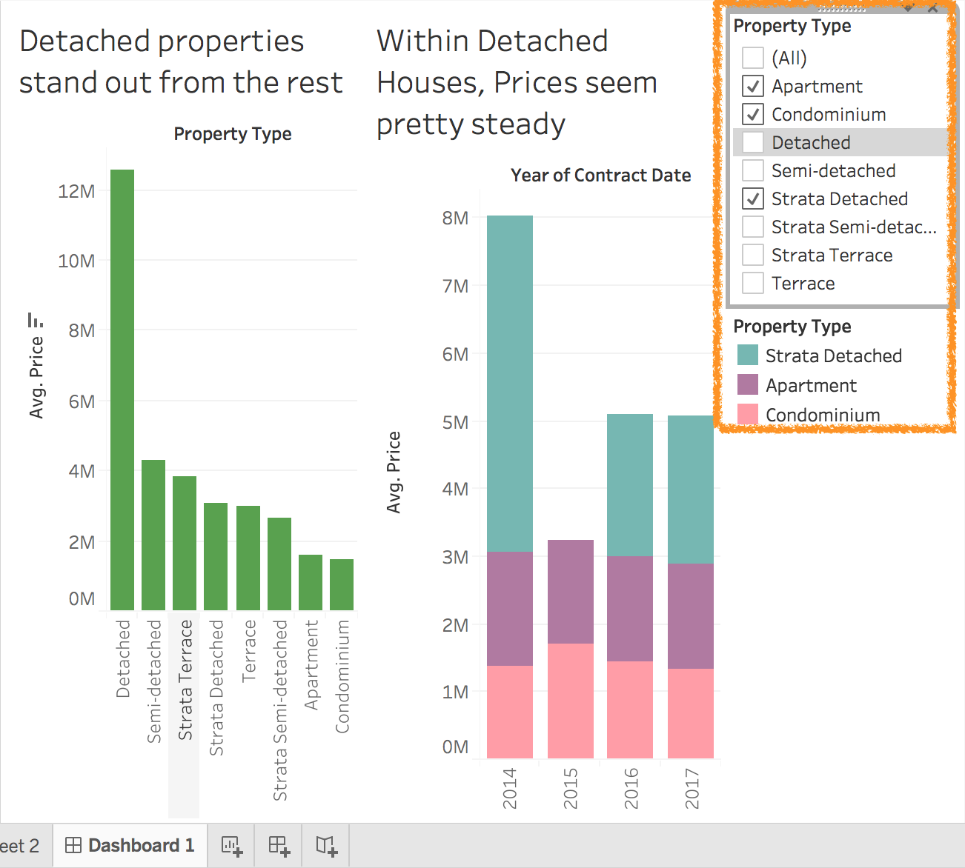

## Test Drive

1. Combine your graphs into a Dashboard with a narrative
2. Explore the Storyline Functionality as well
3. Tableau Help is your best friend